

“Applying Reinforcement Learning to a maze using Q-Learning”

Daniel Elstob

2013-14

Implementation Project Dissertation

School of Computer Science, Mathematics and Business Computing

# Disclaimer

This work is original and has not been previously submitted in support of any other course or qualification.

Daniel Elstob …………………………………... Date ………………………

# Abstract

This implementation project looks at how an Artificial Intelligence can learn and adapt to an unknown environment. Research looks at the different methodologies and techniques that can be used to create the Artificial Intelligence and its behaviour. This project will further research into Reinforcement Learning with focus on Q-Learning. The project demonstrates a program with an Artificial Intelligence that can navigate a maze to find the goal tile without any prior knowledge. In conclusion the project shows how an Artificial Intelligence can adapt to an environment.

# Acknowledgements

Thanks must be given to the dissertation tutor, Dominic Langmead, who has been an excellent mentor throughout the course of the project. Thanks must also be given to indirectly to the software engineers that have created the software that has been used for the project.

Contents

Disclaimer 0

Abstract 0

Acknowledgements 0

List of Figures 3

Introduction & Background 4

1.1 Background 4

1.2 Justification 4

1.3 Implementation and Project 6

Review of Existing Technologies and Systems 9

2.1 Machine Learning Techniques 9

2.2 Introduction to Reinforcement Learning 11

2.3 History of Reinforcement Learning 12

2.4 Advantages of Reinforcement Learning in Games 15

2.5 Current Examples 17

Planning Process 19

3.1 Background 19

3.2 Level Design Drawing 19

3.3 Level Design Documents 20

3.3.1 Software 20

3.3.2 Development Stages 20

Implementation and Testing 21

4.1 Introduction 21

4.2 Creating a maze with directional controls 22

4.2.1 Environment Creation 22

4.2.2 Agent Creation 22

4.2.3 GUI Creation 22

4.3 Adding Q-values to the maze tiles 23

4.3.1 Q-Learning 23

4.3.2 Adding the Q-values 24

4.4 Applying agent decision making using Q-Learning 25

4.4.1 Agent Learning 25

4.5 Alpha testing 26

4.6 Adding customisable options to the GUI 26

4.7 Add an output screen and additional options to GUI 28

4.8 Beta testing 29

4.9 Compile 29

Evaluation 30

5.1 Introduction 30

5.2 Project Successes and Outcomes 30

5.3 Further Work 32

Conclusion 34

6.1 Introduction 34

6.2 Agent 34

6.3 GUI 34

Bibliography 35

Appendix 38

Appendix 1 – Ethics Form 38

Appendix 2 – Level design document 40

Appendix 3 – Initial Planning Process Level Design 41

Appendix 4 – Initial Implementation Level Design 41

Appendix 5 – Alpha Testing Plan 42

Appendix 6 – Beta Testing Plan 44

Appendix 7 – Hypothesis Testing Criteria 48

Appendix 8 – Ability to Learn 48

Appendix 9 – Ability to Learn: Q-Values 49

Appendix 10 – Ability to Adapt 49

Appendix 11 – Ability to Adapt: Q-Values 50

Appendix 12 – CD containing all project files 50

## List of Figures

Figure 1…………………………………………………………………………….……….21  
Figure 2………………………………………………………………...…………………...23  
Figure 3...……………………………………………………..…………………………….24  
Figure 4……………………………………………………………………………………..26  
Figure 5………………………………………………………………………………..……27  
Figure 6………………………………..……………………………………………………28

# Introduction & Background

## 1.1 Background

Machine Learning has become a popular research area in the hope to create artificial intelligence or autonomous agents. There has been a problem for autonomous agents and that is planning a sequence of actions to maximise reward. This is considered a problem because it requires an agent to form a sequence of actions based on its own experience without human intervention. There are also the problems of *“How much training data is sufficient?”* (Mitchell 1997) or *“How can the learner automatically alter its representation to improve its ability to represent and learn the target function?”* (Mitchell 1997).

This project will look at the different method and techniques that can be used to create such an agent that can both learn and use its acquired knowledge to complete a task.

## 1.2 Justification

Many companies have been researching and implementing artificial intelligence or automated intelligence systems into their industries such areas as game development, military and medical.

With the advancement of technology and the average consumer owning more powerful devices, such the Xbox One which *“is the most powerful console”* (Sutton 2013), games developers have been able to create more varied and complex scenarios with smarter artificial intelligence. One of the most recent applications of machine learning techniques being successfully used in a commercial game is HITMAN: ABSOLUTION. This game used Reinforcement Learning for animation control. When asked about why Reinforcement Learning was a promising technique for gaming animation the Technical Producer at IO Interactive replied *“Wouldn’t it be nice to be able to directly feed high-level goals, like “Go to this location” to the animation system, which then automatically and autonomously decides about the best sequence of animations to play in order to achieve the goal”* (Champandard 2012).

Another area that is researching automated intelligence systems is the military. The military is always looking for ways to make warfare more autonomous to reduce the number of casualties. There are many advantages and risks to having autonomous technologies. Major Kenneth Rose of the US Army’s Training and Doctrine Command who was in favour of robotics in the military is quoted saying *“Machine don’t get tired. They don't close their eyes. They don't hide under trees when it rains and they don't talk to their buddies ... A human's attention to detail on guard duty drops dramatically in the first 30 minutes ... Machines know no fear”*  (CBBC 2002).  
There have also been a lot of debates against these robots being developed and incorporated into the military. The current drones are either manned by an operator or have a certain degree of intelligence for example Excalibur which is an *“unmanned air vehicle”* (General Dynamics n.d) that has an *“advanced flight control system”* (General Dynamics n.d) that allows for it to be autonomous meaning the operator will be able to focus on the mission instead of piloting. This is a step in between an operated machine and an autonomous machine. The military hope to have a fully autonomous machine that will be able to choose between targets and which targets to kill. This brings a lot of concerns to some researchers who say there is the threat of such robots turning against those they should protect and that robots must learn to obey a code. A science fiction author named Isaac Asimov created the ‘Three Laws of Robotics’ which are

“*1. A robot may not injure a human being or, through inaction, allow a human being to come to harm.  
2. A robot must obey the orders given to it by human beings, except where such orders would conflict with the First Law.  
3. A robot must protect its own existence as long as such protection does not conflict with the First or Second Law.*” - Three Laws (n.d)

These three laws were created for the story Asimov wrote and aimed to be a framework for the robots behaviour. The robotics community have since adapted and added to the laws to suit their needs.

Lastly in the medical field there has been a system created by IBM called Watson. This is a system capable of *“analysing natural language questions and content well enough and fast enough to compete and win against champion players at Jeopardy!”* (IMB Research 2011). Watson was then applied to the medical field as *“Physicians can use Watson to assist in diagnosing and treating patients by having it analyse large amounts of unstructured text and develop hypothesis based on that analysis”* (Watson at work 2014).

## 1.3 Implementation and Project

***“Can an Artificial Intelligence learn and adapt in a maze in the same way as a human?”***

With this statement as the aim, the project is to create a maze game and an agent that uses machine learning techniques to see if the agent can learn and adapt to the environment, in the same way a human would, to navigate and complete the game. The agent will approach the game with goal directed learning and decision making to complete the game’s long terms goals in the same way a human player would.

Features will be implemented based on research into games design, value systems and exploration vs. exploitation. Research into previous related work will highlight both the successful and unsuccessful features to create a game and an agent with machine learning.

Possible languages to develop the agent for the project are Java, MATLAB, Python, C++ and Julia.

Firstly Java is a popular object-oriented programming language that has a very extensive library and community resources. Two of the best resources for Java are Weka and MALLET. Weka is software developed by the Machine Learning Group at the University of Waikato in New Zealand that incorporates several standard machine learning techniques and is mainly used for data mining. MALLET is a Java-based package for many machine learning applications such as statistical natural language processing, clustering and topic modelling. There are many different integrated development environments’ (IDE) to program in as well. Some of these IDE’s are Eclipse, NetBeans, BlueJ and JCreator. Each with its own use and benefits, for example BlueJ was designed for beginners of the Java language and NetBeans supports multiple languages and the development of applications.

*“MATLAB is another very popular language in both the industry and academia”* (EE Times 2004), invaluable for single processing with an incredible array of libraries that can be used in projects. It is the simplest and most concise language when performing matrix operations. It works best with data and information that is represented as a numeric matrix but is not good for data represented in any other way. MATLAB IDE’s are usually commercial for example one IDE called ED for Windows or another called Crimson Editor.

*“Python is a complete programming solution…it is open source and completely free…as are many of the key scientific libraries. Second it runs natively on Windows, Mac OS, linux… Third, it fits quick scripting and large development projects equally well.”* (Koepke 2010)*.* Python is a good general purpose language to use for initial prototyping as it will check your results very fast but in the long run will run slower than compiled languages like Java unless used with C. It has as a very good library and open source programs such as Scikit-learn, an open source library for machine learning or Pandas, a software library for data manipulation and analysis. There are a lot of different IDE’s for Python, some free open-source and others for commercial and all with their own uses. Some IDE’s that could be used for this project are NetBeans, Eclipse with PyDev and Komodo.

C++ is based on the C language but with a bottom-up approach and used object-oriented programming concepts like classes and objects. *“C++ is a very powerful programming language that exists on virtually every programming platform and is really only rivalled by Java”* (Bolton n.d).This is one of the most popular languages in the programming community as it is not only used in software for video games but across multiple other areas such as application and system software. When it comes to libraries for machine learning or artificial intelligence there is not much support within the community. There are a few partial libraries for example Shark which is open source and contains methods for machine learning techniques such as kernel-based learning algorithms. IDE’s for this language are NetBeans, Notepad++ and Visual Studio.

Julia as a language does not have extensive libraries like some of the other languages mentioned. Julia is an attempt to combine the flexibility and conciseness of other high-level dynamic languages like MATLAB and Python with the speed of low-level statistically typed language like C. This make the syntax very similar to MATLAB however unlike MATLAB for loops are efficient so operations do not need to be vectored. There is only one free open source IDE’s for Julia called Julia Studio or Forio.

# Review of Existing Technologies and Systems

## 2.1 Machine Learning Techniques

Machine Learning is an area of artificial intelligence that allows for computer to learn without the need to be programmed in great detail. It focuses on the development of programs that can learn and adapt to the newly gathered data. There are many different machine learning techniques that can be used for the development of an agent. Some of these methods that will be looked at are Decision Tree Learning, Artificial Neural Networks, Bayesian Learning, Instance-Based Learning, Genetic Algorithms and Reinforcement Learning.

*“Decision Tree Learning is a method for approximating discrete-value target functions, in which the learned function is represented by a decision tree”* (Mitchell 1997). The agent can use the decision tree to sort through a yes-no or if-then scenario to find the solution.

Artificial Neural Networks are computer models that represent an animal’s brain and are capable of both machine learning and pattern recognition. The process of a Neural Network is that data can be input to a neuron which is then passed on to a function and will eventually reach and output neuron, which determines what the data was.

*“Bayesian reasoning provides a probabilistic approach to inference. It is based on the assumption that the quantities of interest are governed by probabilistic distributions and that optimal decision can be made by reasoning about these probabilities together with observed data”*(Mitchell 1997*)*. From this is Bayesian Learning which can be important for machine learning for two reasons, *“algorithms that calculate explicit probabilities for hypotheses”* (Mitchell 1997) and to *“provide a useful perspective for understanding many learning algorithms that do not explicitly manipulate probabilities”* (Mitchell 1997).

Instance-Based Learning is a set of algorithms that compare new problems with those seen in training which have usually been stored in the memory. There are two disadvantages to instance based learning, the first is that the *“cost of classifying new instances can be high”* (Mitchell 1997) and the second is that *“they typically consider all attributes of the instances when attempting to retrieve similar training examples”* (Mitchell 1997) which can result in it finding incorrect data overall but machines the few attributes that are similar.

*“Genetic Algorithms provide an approach to learning that is based loosely on simulated evolution”* (Mitchell 1997) and can mimic the process of natural selection. Genetic Algorithms is generally used for the generation of solutions to optimization and search problems. It does this by *“repeatedly mutating and recombining parts or the best currently known hypotheses”* (Mitchell 1997). There are a few limitations to Genetic Algorithms however, for example they do not scale well with complexity and that the “better” solution is only better in comparison to other solutions.

Reinforcement Learning is an approach for learning through interaction of an environment in the same way humans and animal interact with the environment whilst growing up. It is a learning technique that uses a cumulative reward based system to influence the agent’s decision. It is a technique that differs from others as the correct input and output pairs are not taught to the agent and learned decisions are not corrected if sub optimal.

Markov Decision Processes (MDP) provides a mathematical framework for modelling decision making. MDP’s are used for studying optimisation problems which have usually been solved by Reinforcement Learning.

After researching into some of the main machine learning techniques that could be used for the projects agent, the most suitable is reinforcement learning. This particular machine learning techniques will allow for a better artificial intelligence. Another benefit to this technique is that is works well with other techniques such as Artificial Neural Networks and Markov Decision Processes.

## 2.2 Introduction to Reinforcement Learning

Now that machine learning techniques has been decided more in depth research will be done on this machine learning technique.

Reinforcement Learning is a style of learning all living thing use to learn about the world around them, for example if a child did something good and was rewarded for it; this would be an example of a positive reinforcement. On the other hand if the child were to touch something hot and get burned then that child would learn that whatever they touched produces pain; this is an example of a negative reinforcement. Computers however are not as intelligent and quick learning as human and do not have the same senses either. An artificial intelligence also known as an agent is more alike to a puppy. You cannot tell the puppy what to do as they do not understand, however you can use a reward and punishment system called Reinforcement Learning. An agent can use the same system, if it performs in a way that is wanted it will be rewarded and if it performs wrongly it can be punished.

(Csaba, S. 2009) showed at the most basic level Reinforcement Learning is shown through the use of state, actions and rewards. The state in the environment that the agent is in, this can be information about the health and amount of lives the agent has, the distance from a potential reward like collectables that will increase score or the distance from an enemy. The actions are all of the things that the agent can do to transition from the current state to another state. The rewards are a scalar quantity that is associated with each separate state and the goal of the agent is to gather as much of the reward as possible. The agent will use this method of reward gathering to determine its decision making of which action to take throughout the game.

The issue with this is that if an agent uses Reinforcement Learning but only uses the basic reward system it will become too predictable as the agent will act greedily only taking action to increase its total reward. This shows the lack of planning on a long term goal or the ability to adapt which is what developers will want from Reinforcement Learning. (Harmon, M., E. Harmon, S. S., 1996) showed that at this point implementation of a value system it is necessary to maximise an agent’s reward over the long term as opposed to the short term when only using rewards for decision making. A value is scalar quantity which can be used instead of rewards when determine what actions to take. (Sutton, R., Barto, A. 1998) explained that the reason this is better is that rewards cannot be changed by the agent but values can be. Values are also different as they provide long term viability to an action rather than an immediate return like a reward gives. An example of this is if the agent is provided with two choices one choice that is immediate high reward but gives low rewards in the future and another choice that offers a low reward immediately but high reward in the future. If the agent were to use the basic reward system and greedily choice the first option however with a value system it would choose the second option as it lead to the highest overall reward.

This can further be improved by adding in an exploration system which is where an agent will sometimes make a random decision instead of one based on the highest value. (Coggan, M. 2004) found that this improvement allows for the agent to explore the option that there could be better action it could take that doesn’t follow the value system as well as adding in an unpredictable behaviour.

## 2.3 History of Reinforcement Learning

Reinforcement Learning was first started in psychology and moved into the areas of neuroscience, statistics, cybernetics and computer science. In the early 1990’s interest for Reinforcement Learning gathered within the machine learning and artificial intelligence communities as a way to program agents to carry out a task without specifying how to complete it.

With the machine learning and artificial intelligence communities accepting Reinforcement Learning as a new area to research into and to learn about, this learning technique could be used to train computers to do numerous tasks such as playing games, scheduling plans and controlling a robot. Reinforcement Learning is something that all living things can do. It is learning how act within an environment and how to deal with certain situations to reach a goal. To allow for the computer, more commonly referred to as an agent, to learn you give it a goal to work toward and it will interact with the environment to find the most efficient choice of actions in order to achieve the goal. It will then learn, based on previous experience, to estimate what actions will provide the greatest rewards within different situations until it eventually finds the most optimal policy.

One of the first successful applications of Reinforcement Learning in games was in Backgammon created by Gerald Tesauro in 1994 (Tesauro, G. 1994). Backgammon is a board game for two players that is played by rolling a dice and playing pieces according to the roll. The game is won when one player removes all of their pieces form the board before their opponent. Gerald Tesauro’s version of the game was called a TD-Gammon as it was based off of the TD Reinforcement Learning algorithm (Sutton, R., Barto, A. 1998) and was a self-teaching Backgammon program that achieved master-level play by playing itself and learning from the results. It was a very good example to show the level at which and agent with Reinforcement Learning can play a game when given only the basic rules of the game to then learn the strategies and play styles and then to be at a level where it could play against world-class human opponents and unlike human players it will not tire or make errors in judgement due to carelessness or lack of interest.

As Reinforcement Learning has, for the majority, been an academic research area the commercial game developers have not used this machine learning technique. This is understandable as most games do not need the ability to learn. Would the player have noticed if the enemies were learning and would it be an improvement on gameplay or would it be a waste of time and money for the developer?

There have however been game companies that have seen the potential of Reinforcement Learning and have attempted to incorporate it into their games. Black & White a game developed by Lionhead Studios in 2001 for PC and Mac OS was a game that applied Reinforcement Learning onto a character. Black & White was a god game in which the player would be a newly created god and takes control over numerous villages across several islands. The unique gameplay feature in this game is a creature that the player can raise and teach. The creature is taught by using Reinforcement Learning, if the creature does something wrong or something the player does not want it to do, the player can slap the creature as punishment. Alternatively if the creature does something the player does approve of the player can stroke the creature as a reward. The player’s creatures will remember the player’s response to various actions and will gradually change both its behaviour and appearance. The player’s alignment in the game is independent on the creatures, meaning you could be an evil god but have a good creature. IGN a game reviewer gave this game 9.7/10 saying *“You’ll play this game until you go insane…just look at me. Multiplayer won’t extend life much, but the ability to imbue various creatures with different traits brought me back again and again”* (IGN 2001). This shows that a game with Reinforcement Learning can have success and gain a lot of popularity with an expansion and a sequel following in later years.

Another game that uses this machine learning approach is Tao Feng: First of the Lotus. A game developed by Studio Gigante for the Xbox in 2003. After the success of Forza Motorsport and its positive response to the behavioural cloning techniques that were used to model human driver and then compete against them Ralf Herbrich, Thore Graepel and Julian Gold started to investigate into machine learning in fighting games. The result was a fighting game called Tao Feng: First of the Lotus (Ross 2004). They applied Reinforcement Learning onto the Artificial Intelligence and allowed it to play for a few games. The rewards were the main motivator for the Artificial Intelligence with it being rewarded for reducing the opponent’s health and receiving no reward if its own health went down. At first the agent wouldn’t do anything until around 15 minutes of gameplay at which point the agent learnt how to play very aggressively and performed much better not making any action that didn’t lead to success. This can be beneficial factor to developers as they would only be required to write very little code themselves e.g. 10 lines explaining the rule rather than 5000 lines that scripts out all possible moves and reaction to a situation. The successful implementation of Reinforcement Learning in this games showed that it is a viable solution for building an adaptive combat Artificial Intelligence. With its flexibility and effectiveness it could be carried across to other similar games.

Another game that has been used to demonstrate the effectiveness of Reinforcement Learning is Civilization IV, a game developed by Firaxis Games for the PC in 2005 and Mac OS X in 2006. Civilization IV is a turn-based strategy in which the player will be spawned in a random location on a tile map along with other civilizations. With civilizations having a set amount of personalities, which may be war-seeking, culture-orientated or expansion-directed and assuming that each personality is favourable depending on the situation and environment the agent can learn when to use which personality. Other state feature that can affect decision making is the military strength on the agent and opponents, the amount of unoccupied land and the technological or cultural advancement that have been made by either the agent or opponents. Using methods such as Q-learning, used for finding the optimal action-selection policy for any MDP, and model-based Dyna-Q, a simple architecture with the major function needed for and on-line planning agent, and using a fixed set of state feature it was demonstrated that even a complicated games can have Reinforcement Learning implemented and the current Artificial Intelligence improved upon.

## 2.4 Advantages of Reinforcement Learning in Games

Adding in learning to games allows for an improved gameplay for the player. Firstly it means better artificial intelligence behaviour as it will be more variable as it is not following a programming script, challenging because it is learning the player’s strategies and play style, believable because it acts more human like in the way it will react and respond to certain situations and will be more robust that a scripted program as it will be able to learn, react and respond to strategies that it has not seen before.

Another improvement to the gameplay is that it will be a more personalized experience and have more replay ability. This is because of the Artificial Intelligence that develops through the game as the player does. This can be shown with Black & White, a game that can be replayed and have a different play style depending on how the player interacts with the world. The Artificial Intelligence will also learn the model of the player and counter the player’s style and strategies. This can be shown already in games with a limited amount of responses like checkers or backgammon.  
Finally it can provide new types of gameplay. There can be trainable character like in Black & White which allow for further personalized gameplay and there is the ability to create an ideal model like in Tao Feng.

Another area that could be beneficial for the game developers is the marketing hype they could create. An example from this would be the A.I. Drivatar technology (Microsoft 2005) from Turn 10 Studios for Forza Motorsport on Xbox who allowed the players to *“Train your own A.I. "Drivatars" to use the same racing techniques you do, so they can race for you in competitions or train new drivers on your team. Drivatar technology is the foundation of the human-like A.I. in Forza Motorsport”* (John Laird & Michael van Lent 2005).

For the demographic that enjoyed car racing games an amazing feature that was adding into the Forza Motorsport the ability to create a clone of the player using there play style and their reaction to state situations to then compete against the player was something that hadn’t been done before.

Or the hype from Black & White preview which is quoted saying *“Your creature learns from you the entire time. From the way you treat your people to the way you act toward your creature, it remembers everything you do and its future personality will be based on your actions. (Preview of Black and White)”* (John Laird & Michael van Lent 2005). A game that had a feature depending on the actions you could have made subconsciously that didn’t have too much effect on the storyline but showed the player their impact on the environment around them as the interacted with it over time.

## 2.5 Current Examples

There are a few examples that show board games can use Reinforcement Learning. The first is Backgammon. In 1992 Gerald Tesauro created a computer backgammon program called TD-Gammon. *“TD-Gammon is a neural network that is able to teach itself to play backgammon solely by paying against itself and learning from the results, based on the Temporal Difference Reinforcement Learning algorithm (Sutton 1988)”* Tesauro (1994).

This program started out with no knowledge of the game except the basic description of the board and was able to learn to play just slightly below a master level. Another benefit that came out of this program is that is explored strategies that the human players had not and made advancements in the theory of backgammon play.

Another example is Blackjack. Charles de Granville saw blackjack as a game that Reinforcement Learning could be applied to using Q-Learning. *“The objective of the game is to win money by obtaining a point total higher than the dealer’s without exceeding 21. … This presents an interesting opportunity for machine learning algorithms. Supervised learning techniques may provide a viable solution, but do not take advantage of the inherent reward structure of the game. Reinforcement Learning algorithms generally perform well in stochastic environments, and could utilize blackjack's reward structure”* De Granville (n.d).

The purpose of his project was to find the most *“optimal blackjack strategy using the Q-learning algorithm”.*

A genre that would work well with Reinforcement Learning is real time strategy. Games that follow this this genre require a lot of coded strategies for the computer players to use against a human player. This can be a difficult task for the developers as they need to create an artificial intelligence that can still be beaten by the human player but is challenging enough for the game to be fun. One game from this genre that has been suggested as a possible game to use Reinforcement Learning is Civilization IV. Civilization IV is a game with multiple win scenarios allowing for the Artificial Intelligence to take different strategies to win the game. A paper written by Amato, C. & Shani, G explores the possibility of this game using three different Reinforcement Learning techniques and how the techniques can further advance the strategies within the game.

# Planning Process

## 3.1 Background

This chapter is to highlight the planning that has been done for the project based of the aims and objects chosen and shown in the ethics from (Appendix 1). The documentation in the appendix (Appendix 2) of this document will show the development to prepare for implementation. The different areas of the project’s development have been broken up into sections that will explain their purpose.

## 3.2 Level Design Drawing

The level design drawing is an aerial view of the environment and is used to design the layout maze (Appendix 3). This will likely change and develop throughout the project during implementation to make it easier or more difficult depending on the results. The current drawing is the implementation ready design and the shape of the level was decide on based from the literature review which showed that a maze that provided many different option for the artificial intelligence to take would produce a more varied result.

The design shows the shape of the level which forms a maze and will require the artificial intelligence to navigate through the maze and reach the goal. As reinforcement learning will be used the placement of a reward will also provide a goal for the artificial intelligence and to see the decision making between the different types of goals, the short term goal of rewards that can increase a score or the long term goal of completing the maze.

## 3.3 Level Design Documents

### 3.3.1 Software

The chosen software, NetBeans, for the project has been chosen as it provides the best resources or results for the development of similar projects. Java was chosen as the programming language as it contains a variety of libraries for the development of artificial intelligence projects.

Adobe Photoshop was chosen for the creation of the maze textures and the artificial intelligence image. Adobe Photoshop has been chosen for its many features to provide good quality assets and

### 3.3.2 Development Stages

This section covers the stages need to be completed in order to complete this project. The first stage was planning and prioritising which areas of the project to do. The project could be broken down into a few main stages. Planning the project, assets creation and testing.

The first stage consisted mainly of planning what software to use for what purpose, whether it is Java SDK for the software creation or Adobe Photoshop for asset creation. The second stage was the asset creation stage which is the creation of the textures for the maze and the artificial intelligence as well as any addition reward textures that would be implemented to the maze. The third and final stage involved two separate stages, alpha and beta, which would be used to assure the project is working correctly. For the beta test which is the main test to finalise if the project if fully working without errors a beta test checklist was created.

# Implementation and Testing

## 4.1 Introduction

In this chapter the implementation will follow the development stages that are listed in the program specification (Figure 1). This chapter will also cover all problems encountered through the development and testing and how they are resolved.

Project Title: Applying Reinforcement Learning to a maze using Q-Learning.  
  
Project Aims: The aim of his project is to create an artificial intelligence that can learn and adapt to a maze environment.   
  
Project Description:

1. Create a program that has a maze, and buttons that control movement.
2. Apply Q-values to the maze tiles and add arrow graphics to show which direction has the highest Q-value.
3. Remove directional buttons and add in a move button with Q-Learning algorithm, a reset button to reset the program, a customisable initial Q-value of the tiles, a label showing the number of move taken, a label showing the cumulative reward, and make the tile’s Q-values visible.
4. Add additional option for the user to control the program. Add in a customisable discount value, a customisable greedy exploit value and a customisable fixed alpha. Change the background colour to black and the arrow graphics to yellow. Add in colour green for the two goal tiles and red for the two negative Q-value tiles.
5. Add in a trace to console tick box and a show Q-value of tiles tick box. Add a text area to the program to show the output of the program which can be show form the trace to console tick box

Deliverables: The above deliverable need to complete by Wednesday 19th March 2014.  
(Figure 1)

## 4.2 Creating a maze with directional controls

### 4.2.1 Environment Creation

As the environment the agent would be in was a maze the plan from the chapter Planning Process was to create the assets of the maze using Adobe Photoshop and import them in however as the project started further research was put into how the maze could be created and it was then decided to create an open maze using a grid layout (Figure 2). This style of maze would be able to show how the agent navigates towards an end goal in an open 10 tiles by 10 tiles maze that had walls only on the border. The reason for this is that with an open maze the agent would enter the environment knowing nothing about it and have to find the goal and avoid the negative tiles showing how the agent learns and progresses through an environment it knows nothing about.

### 4.2.2 Agent Creation

Now that an environment had been created next was the agent itself. The starting stage was to create an agent that could be controlled by human input through the use of buttons. This way when the GUI is created it could be tested it would show if the agent could move around the maze in all direction and to check the collisions of the borders.

### 4.2.3 GUI Creation

The final step was to create the GUI to run the program in. At this point in the implementation the level design had changed from the initial design (Appendix 3) to an implementation design (Appendix 4). The new GUI would have a larger maze without and inner walls and an agent that could be controlled through directional buttons. The new design is planned to have negative value tiles so that the agent will show learning when avoiding them. This early version of the program was to test if the maze and movement worked (Figure 2).

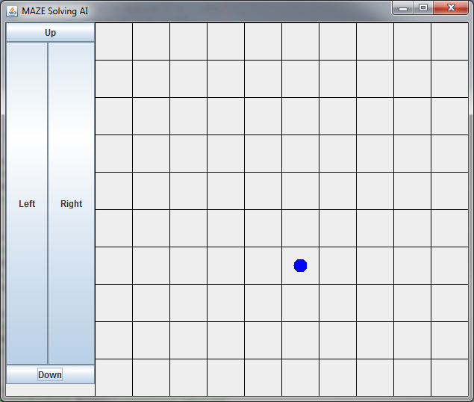Figure 2

## 4.3 Adding Q-values to the maze tiles

### 4.3.1 Q-Learning

After researching about Reinforcement Learning further research was done into the different algorithms that could be used by the agent for learning. The result from the research was Q-Learning, an optimal action selection policy, which works by learning action-value functions. This means for any given action in a state will be followed by an optimal policy. In terms of the project for any movement in a maze tile an optimal policy will be created or updated. With the optimal Q-Values applied to the maze tiles the agent will be able to take the optimal path to the end goal. Q-Learning also has the strength that it doesn’t need to have a model of the environment and the environments Q-Values in order to make decisions and take actions.

### 4.3.2 Adding the Q-values

Once the Q-Learning algorithm had been chosen it was then applied to the environment and tiles had a Q-value placed on them. Now the tiles had Q-values that would change depending on the direction the agent went and the agent would use the Q-value to choose a direction. To help show which direction the agent thought was most optimal four arrow graphics were placed onto the tiles (Figure 3).

Figure 3

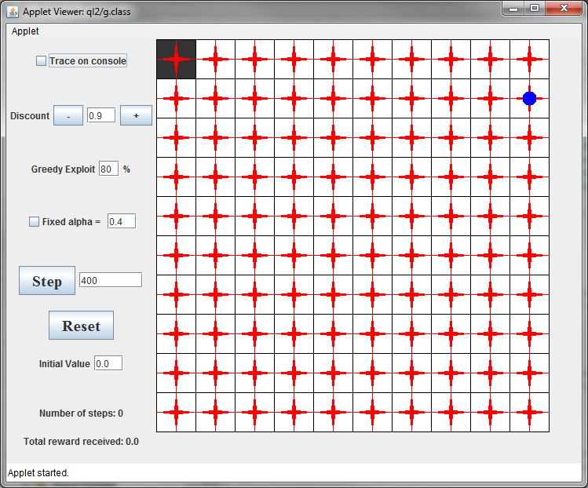

## 4.4 Applying agent decision making using Q-Learning

### 4.4.1 Agent Learning

With the foundations working it was finally the stage to work on answering the hypothesis “Can an Artificial Intelligence learn and adapt in a maze in the same way as a human?”. The aim was to remove the ability for the user to choose the movement direction of the agent which was done by replacing the buttons as shown in figure 3 and replacing them with a single move button as shown in figure 4. This button would use the Q-Learning algorithm to decide on the direction.

With the Q-Values already on the tiles all that was needed was to apply a discount which determines the importance of future rewards; 0 being short term rewards and 1 being long term rewards, an alpha which determines to what extend the newly acquired information will override the old information; 0 the agent learns nothing and 1 will make the agent consider only the most recent information, and the learning algorithm.

To allow for a faster running test of the program the movement button will run for however many times specified in the input box. An input box for the tiles initial Q-values has also been put into the GUI so that the user can choose what the tiles are worth. This feature can affect how the agent acts in the maze, for example of the values were to be set to -1.0 then the agent which has the aim of getting a high positive reward score will act differently than an agent in an maze with the tile values at 0.0. So that the user can see how the Q-values change from their initial value choice the Q-values of the tiles have been set to visible. Two labels have also been added to show the number of moves the agent has taken and the cumulative score the agent has achieved in those movements.

Figure 4

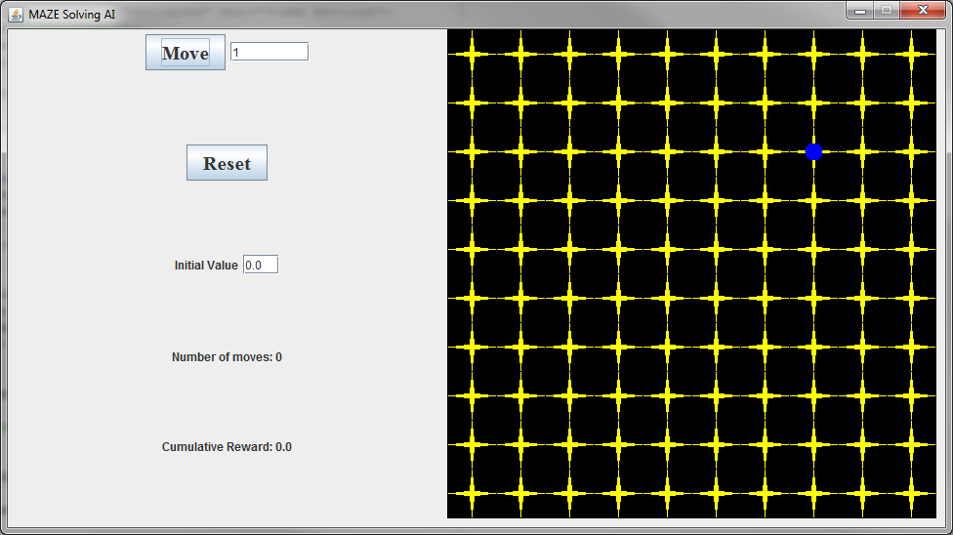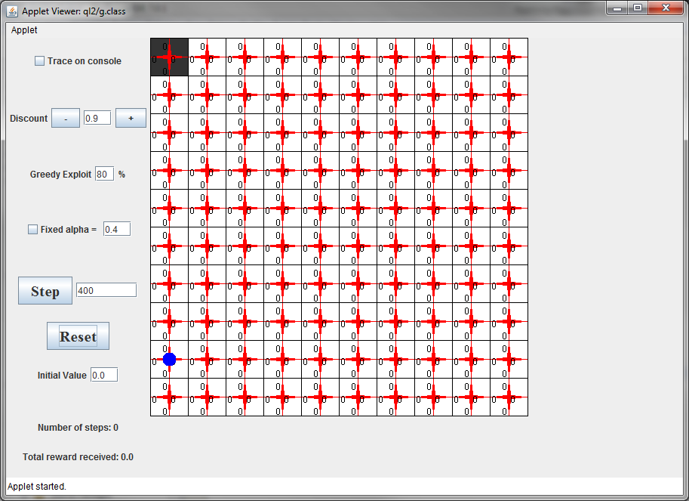

## 4.5 Alpha testing

At this stage in development the program was ready for alpha testing. A testing plan was carried out (Appendix 5) that tested all features of the program to ensure it was working correctly. As it passed the test without any issues the program could move onto the next stage.

## 4.6 Adding customisable options to the GUI

At this point of the development stage the program was working as expected and all further changes to the program are to allow the user to alter the Q-Learning algorithm. The first change that was made was to make the two good tiles turn green and two bad tiles turn red when the agent landed on the tile. To do this a method was used that would start with a black tile and would change colour specific to its value, e.g. a high value would turn green. This method would also change the surround tiles as the agent learnt that these would lead to the goal tile. Now that the maze had a black background it was decided that the optimal direction arrow graphics would be yellow and the Q-values white as shown in figure 5. Other than changes to the visual side of the program additional features were added for the user. The options to change the discount, greedy exploit and fixed alpha were added. The discount value determine the importance of future rewards, a factor of 0 (short sighted) will make the agent consider current rewards and a factor of 1 (long sighted) will make the agent strive for long term high rewards however a value equal or higher than 1 may cause the action values to diverge. The greedy exploit is how greedy the agent will act in its decision making. In figure 5 the greedy exploit is set to 80%, this means that if will move toward the direction that will give it the largest Q-value reward 80% of the time and move randomly the other 20%. Alpha is the learning rate of the agent and it determines to what extend the newly acquired information will override the old information. A factor of 0 will make the agent learn nothing and a factor of 1 will make the agent consider only the most recent information. The fixed alpha will allow the user set the learning rate of the program.

Figure 5

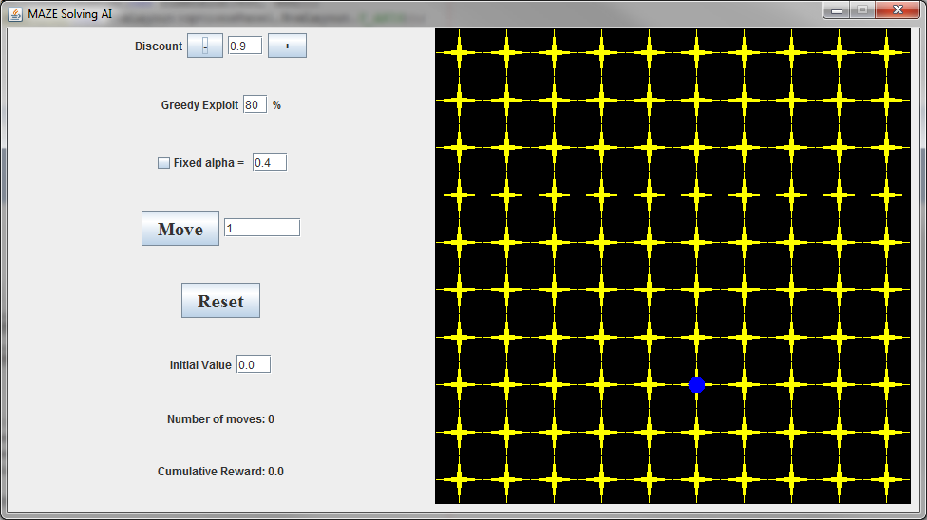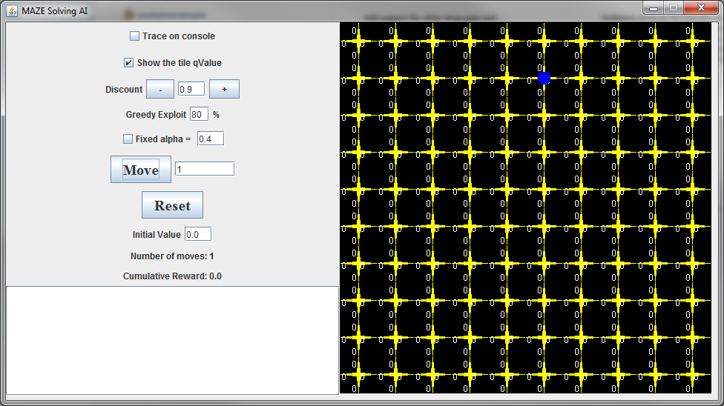

## 4.7 Add an output screen and additional options to GUI

This was the final stage in the program creation and the program was working as expected however when running the program and having the agent make large amount of moves the Q-value labels on the tiles can become obstructive of the program. To solve this issue a check box was placed into the GUI to allow a user to turn the Q-value labels on or off. A final change to the GUI design was to add in a check box with the label “Trace on console” and a text area at the bottom as shown in figure 6. The trace on console option, when selected, would display all the movement information that normally would go into the IDE’s console. The information would contain the co-ordinates of the tiles, times visited, the old and new Q-values etc. This information can be useful to the user to further show how the options affect the agent.

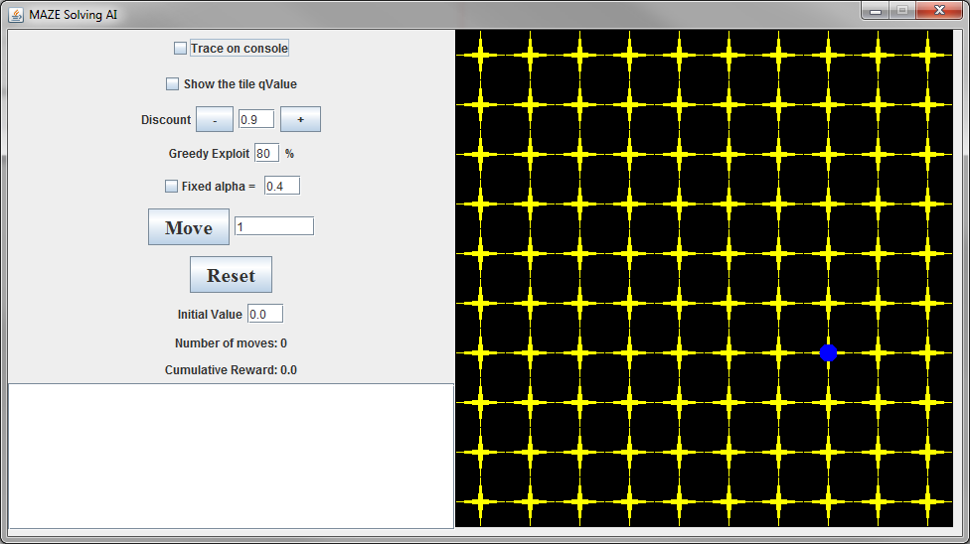Figure 6

## 4.8 Beta testing

Beta testing is the final stage to see if a program is ready for release. The testing plan (Appendix 6) showed that almost all the program worked correctly however the text area at the bottom of the GUI (Figure 6), which should have output the movements similar to how the IDE’s console would, listed the movements across the text area and out of view. This problem was fixed with two changes; the first was to place the text area into a scroll pane to allow the user to scroll in all direction if they wanted to see the information, the second change was to alter how the information was to be laid out inside the box going line by line rather than a single sentence.

## 4.9 Compile

With the program having no remaining issues it was ready for compiling. As the program is created through three different classes it was necessary to compile them into one executable file which will allow for the user to run the program from outside of the IDE.

# Evaluation

## 5.1 Introduction

In this chapter the project will evaluated according to Gibbs model of reflection and the program specification (Figure 1).The project will be critically evaluated on whether it met objectives, the learning outcomes from this project and areas of further work. The findings of the project will be presented and describe how they support the hypothesis.

## 5.2 Project Successes and Outcomes

The original aim of this project as outlined in the ethics form (Appendix 1) was to find out whether an Artificial Intelligence can learn to play a game as well as a human using the methodology Reinforcement Learning. This would be done using a level design similar to that of a game (Appendix 3). After starting to research into the different ways that Reinforcement Learning could be used, the aim of this project changed and instead would be to create and implementation project that could answer the question “Can an Artificial Intelligence learn and adapt in a maze in the same way as a human?” so a new level design was created also (Appendix 4). With this as the new aim, further research went into finding out all the different styles of machine learning as listed in the chapter Review of Existing Technologies and Systems. From this research focus on a single style of learning and further research specifically aimed at that style and how it was used. Due to time constraints it was decided that instead of putting too much time into further researching the specific style and all is algorithms that is would be better to move into the implementation stage which would be carried out according to the program specification (Figure 1) and any unknown knowledge that was need to be learned along the creation of the program. This would quickly become a necessary thing to do as at point through the project certain skills needed to be learned in order to achieve the project’s success.

After creating the GUI and a basic environment how the agent would learn became an issue. It was decided that the learning style within Reinforcement Learning that would be used was Q-Learning, as stated in the chapter Review of Existing Technologies and Systems that is was used for finding the optimal action-selection policy which would work well to navigate a maze. Q-Learning allowed for many feature in the maze for example the Q-values of the tiles and the optimal direction arrows that were based of the Q-values. These features help the user to understand how the agent is making its decisions.

One outcome from the project that was not intended but necessary to have some additional features was the background of the grid. In earlier version of the program (Figure 3) the background was white. This was the intended colour however in order to add in the feature of changing the colour of the two positive and two negative tiles and the surrounding tiles the background had to start out as black.

With the final version of the program (Figure 6) a test plan (Appendix 7) for finding out whether the project had proved the statement “Can an Artificial Intelligence learn and adapt in a maze in the same way as a human?”. The first test is whether the agent can learn or not. To test this the program was run 800 times to allow the agent to move around the maze and learn about the environment it was in. The agent was able to successfully learn the positions (Appendix 8) and Q-Values of the tiles (Appendix 9). The second test is whether the agent can adapt or not. To test this the program was run over 23000 times to fully show how the agent is adapting to the negative value tiles and navigating around them leaving a path (Appendix 10) which is increasing the value of the path tiles (Appendix 11). Although the second test does prove that the agent is adapting to the knowledge it has learnt the ability to adapt can also be proven by the fact that when the program is first run the agent has no information about the environment that it is in and that when the agent moves to a positive value tile the agent is randomly placed in the maze meaning it has to adapt to possibly unknown area of the maze and navigate back to the positive tiles.

Following the testing and analysing of the program the agent was successful in its ability to both learn and adapt meaning the statement “Can an Artificial Intelligence learn and adapt in a maze in the same way as a human?” has been proven to be true.

## 5.3 Further Work

The project successfully answered the statement and showed that an artificial intelligence, or agent, can learn to complete a maze without any prior knowledge of its environment however there are areas of this project that can be further worked on. The two areas that can be further worked on are the agent and the GUI.

Firstly the agent can have many additional features such as additional algorithms, diagonal movement, a decaying path and additional agents. In this project the algorithm used to show Reinforcement Learning was Q-Learning however other algorithms could have been used such as SARSA (State-Action-Reward-State-Action), an algorithm for that allows the agent to interact with the environment which updates the policy and then makes a decision based of that policy. Another algorithm that could have been used is Temporal Difference (TD), an algorithm that is a prediction method which has been successful in solving Reinforcement Learning problems before for example TD-Gammon (Tesauro, G. 1994). Different algorithms would allow the user to see how each algorithm affected the learning rate and the decision making of the agent.  
  
With the current project the agent can only move in for directions between maze tiles however adding in the ability for the agent to move diagonally would open up new decision making and allow for a different way of exploring the maze.   
Another feature to add into the agent would be for it to show a decaying path. This feature would allow the user to see where the agent has previously been for a few tiles and having the path decay would mean that the maze doesn’t become filled with path textures. In an earlier version of the project the GUI had a tracing check box that output the information about the agent every move, one piece of information was the co-ordinates of the tiles as the agent moved between them and the amount of tiles the agent had visited those tiles.  
  
A final feature to add in is additional agents. This would allow for the for the user to set each agent a different algorithm to show and compare how the algorithms being used can affect the learning rate, how they interact with each other and the environment they are in.

Secondly the GUI could have improvements such as an editable map whilst the program in running and visual options that the user could select.  
Having an editable map that would allow the user to add, remove or edit things within the maze. The user could choose where the agent will start from, the positions of the positive and negative tiles and a adding in other features such as walls that the agent would need to navigate around.  
  
On the GUI there is an option to show or hide the Q-Values of the tiles as it is useful to see the Q-Value of each tile direction however it can become too much information making hiding the information necessary. An additional feature to this could be to show only the Q-Value of the optimal direction rather than all four directions.  
  
Lastly if other algorithms are added in, a feature that would allow the user to choose the algorithm for the agent to use either through a check box or drop down box would allow the user to easily select and compare algorithms from a stand-alone version of the program rather than change it within the code of the source files.

# Conclusion

## 6.1 Introduction

In this chapter the project will be discussed on how it could have been done with the benefit of hindsight. The areas that will be covered will be the agent, the GUI and the environment the agent was in. The majority of this chapter will cover similar areas to the further work section of the evaluation chapter.

## 6.2 Agent

As specified in the previous chapter there are many different additions that could have been put into the project. If this area of the project were to be done again the main change would be learning about the other different algorithms and implementing them into the project.

Another change with hindsight would be to plan, design and implement an enemy agent that would have the similar learning algorithms however instead of the end goal being a tile that gives a positive reward like the first agent it would receive a positive rewards from colliding with the first agent and respectively the first agent would receive a negative reward from the collision. This change would show a more advance demonstration of how the agents learn and adapt within the environment.

## 6.3 GUI

The two main features that would be implemented with hindsight are the ability to edit the maze while the program is running and additional GUI options as mentioned in the previous chapter. With the editable maze it would allow for the user to test more scenarios and see how the agent reacts. Additional GUI options would also allow the user to test more scenarios and have much more specific and complex tests

# Bibliography

Sutton, S. S., & Barto, A. G. (1998) *Reinforcement Learning: An Introduction.* Cambridge, MA : MIT Press.  
Mitchell, T. M. (1997) *Machine Learning* New York City, NY: McGraw - Hill

Harmon, M. E., & Harmon, S. S. (1996) *Reinforcement Learning: A Tutorial* Retrieved from <http://www.nbu.bg/cogs/events/2000/Readings/Petrov/rltutorial.pdf>

Coggan, M. (2004) *Exploration and Exploitation in Reinforcement Learning* Retrieved from <http://www.cra.org/Activities/craw_archive/dmp/awards/2004/Coggan/FinalReport.pdf>

Szepesvari, C. (2009) *Reinforcement Learning: Algorithms for MDPs*. Retrieved from <https://www.cs.ualberta.ca/system/files/tech_report/2009/TR09-13.pdf>

Björnsson, Y., Hafsteinsson, V., Jóhannsson, A., & Jónsson, E. (2008). Efficient use of Reinforcement Learning in a computer game. *Proceedings of International Journal of Intelligent Games & Simulation*. Retrieved from <http://webdocs.cs.ualberta.ca/~yngvi/pdf/BjornssonHJJ04.pdf>

Amato, C. & Shani, G. (n.d) *High-level Reinforcement Learning in Strategy Games.* Retrieved from <http://people.csail.mit.edu/camato/publications/LearningInCiv-final.pdf>

Tesauro, G. (1994) *TD-Gammon, a self-Teaching Backgammon Program, Achieves Master-Level Play.* Retrieved from <http://www.tnnls.org/adp/adp-cdrom/Tesauro-1994.pdf>

de Granville, C. (n.d) *Applying Reinforcement Learning to Blackjack Using Q-Learning.* Retrieved from <http://www.cs.ou.edu/~granville/paper.pdf>

Laird, J., E. & van Lent, M. (2005) *Machine Learning for Computer Games* Retrieved from <http://research.microsoft.com/en-us/collaboration/papers/machinelearningforcomputergames-gdc2005.pdf>

EE Times (2004) <http://www.eetimes.com/document.asp?doc_id=1151422> Retrieved January 19, 2014

IGN (2001) <http://uk.ign.com/articles/2001/03/27/black-white-3> Retrieved December 20, 2013

Ross, S. (2004) <http://research.microsoft.com/en-us/news/features/game_ai.aspx> Retrieved January 20, 2014

Microsoft (2005) <http://research.microsoft.com/en-us/projects/drivatar/forza.aspx> Retrieved January 20, 2014

Champandard, A., J. (2012) <http://gameaiconf.com/vienna/schedule/animation-controllers/> Retrieved January 20, 2014

CBBC (2002) <http://news.bbc.co.uk/cbbcnews/hi/teachers/citizenship_11_14/subject_areas/scientific_development/newsid_1923000/1923299.stm> Retrieved February 10, 2014

General Dynamics (n.d) <http://www.gdrs.com/robotics/programs/program.asp?UniqueID=26> Retrieved February 10, 2014

Three Laws (n.d) <http://en.wikipedia.org/wiki/Three_Laws_of_Robotics> Retrieved February 10, 2014

Sutton, J. (2013) <http://www.game-debate.com/news/?news=10162&title=Microsoft+Director+Claims+Xbox+One+Is+The+Most+Powerful+Console> Retrieved March 1, 2014

IBM Research (2011) <http://researcher.ibm.com/researcher/view_project.php?id=2099> Retrieved February 29, 2014

IBM (2014) <http://www.ibm.com/smarterplanet/us/en/ibmwatson/> Retrieved February 29, 2014

Watson at work (2014) <http://www.ibm.com/smarterplanet/us/en/ibmwatson/work.html> Retrieved February 29, 2014

Koepke, H. (2010) <http://www.stat.washington.edu/~hoytak/blog/whypython.html> Retrieved April 27, 2014

Bolton, D. (n.d) <http://cplus.about.com/od/introductiontoprogramming/p/profileofcpp.htm> Retrieved April 27, 2014

# Appendix

## Appendix 1 – Ethics Form





## Appendix 2 – Level design document

Software

* Java SDK : NetBeans
* Adobe Photoshop

Development Stages

* Create a GUI with directional controls
* Add Q-values to maze tiles
* Remove directional controls and in button using Q-Learning algorithm
* Alpha testing
* Add more customisable options to the GUI
* Add an output screen and additional options to GUI
* Beta testing
* Compile

## Appendix 3 – Initial Planning Process Level Design



## Appendix 4 – Initial Implementation Level Design



## Appendix 5 – Alpha Testing Plan

|  |  |  |  |
| --- | --- | --- | --- |
| What is being tested? | Testing Method | Expected Result | Actual Result |
| Move Button | Button Pressed | Action listener registers user input and moves agent specified number of moves. Changes initial value. | Action listener registered user input and moves agent specified number of moves. Changes initial value. |
| Movement Input Box | Values Input | Allows for user input | Allows for user input |
| Reset Button | Button Pressed | Resets all values | Resets all values |
| Initial Value Input Box | Values Input and Move Button Pressed | Allows for user input and changes tile values | Allows for user input and changes tile values |
| Number of Move Label | Move Button Pressed | Changes based on agent movement | Changes based on agent movement |
| Cumulative Reward Label | Move Button Pressed | Changes based on agent movement | Changes based on agent movement |
| Tile Q-value - Up | Move Button Pressed | Value changes with initial value and agents movement | Value changes with initial value and agents movement |
| Tile Q-value - Right | Move Button Pressed | Value changes with initial value and agents movement | Value changes with initial value and agents movement |
| Tile Q-value - Down | Move Button Pressed | Value changes with initial value and agents movement | Value changes with initial value and agents movement |
| Tile Q-value - Left | Move Button Pressed | Value changes with initial value and agents movement | Value changes with initial value and agents movement |
| Arrow Graphics - Up | Move Button Pressed | Direction changes with agents movement | Direction changes with agents movement |
| Arrow Graphics - Right | Move Button Pressed | Direction changes with agents movement | Direction changes with agents movement |
| Arrow Graphics - Down | Move Button Pressed | Direction changes with agents movement | Direction changes with agents movement |
| Arrow Graphics - Left | Move Button Pressed | Direction changes with agents movement | Direction changes with agents movement |
| Agent Graphic | Move Button Pressed | Graphic moves when move button pressed | Graphic moves when move button pressed |

## Appendix 6 – Beta Testing Plan

|  |  |  |  |
| --- | --- | --- | --- |
| What is being tested? | Testing Method | Expected Result | Actual Result |
| Trace on console checkbox | Checkbox Pressed and Move Button Pressed | Allows checkbox to be pressed and when move button pressed output information to GUI console | Allows checkbox to be pressed and when move button pressed output information to GUI console |
| Show the tile Q-Value checkbox | Checkbox Pressed and Move Button Pressed | Allows checkbox to be pressed and when move button pressed shows or hide the tile q-values | Allows checkbox to be pressed and when move button pressed shows or hide the tile q-values |
| Discount Button - (-) | Discount Button Pressed | Action listener registers user input changes the discount value in the input box and when move button pressed changes the discount to specified value | Action listener registers user input changes the discount value in the input box and when move button pressed changes the discount to specified value |
| Discount Button - User Input | Values Input | Allows user input and when move button pressed changes the discount to specified value | Allows user input and when move button pressed changes the discount to specified value |
| Discount Button - (+) | Discount Button Pressed | Action listener registers user input changes the discount value in the input box and when move button pressed changes the discount to specified value | Action listener registers user input changes the discount value in the input box and when move button pressed changes the discount to specified value |
| Greedy Exploit - User Input | Values Input | Allows user input and when move button pressed changes the greedy exploit value to specified value | Allows user input and when move button pressed changes the greedy exploit value to specified value |
| Fixed Alpha - checkbox | Checkbox Pressed and Move Button Pressed | Allows checkbox to be pressed and when move button pressed changes the alpha to specified value | Allows checkbox to be pressed and when move button pressed changes the alpha to specified value |
| Fixed Alpha – User Input | Values Input | Allows user input and when move button pressed changes the alpha to specified value | Allows user input and when move button pressed changes the alpha to specified value |
| Move Button | Move Button Pressed | Action listener registered user input and moves agent specified number of moves. Changes initial value. | Action listener registered user input and moves agent specified number of moves. Changes initial value. |
| Movement Input Box | Values Input | Allows for user input and when move button pressed moves agent the specified value | Allows for user input |
| Reset Button | Button Pressed | Resets all values | Resets all values |
| Initial Value Input Box | Values Input | Allows for user input and when move button pressed changes the tiles q-values to specified value | Allows for user input and when move button pressed changes the tiles q-values to specified value |
| Number of Move Label | Move Button Pressed | Changes based on agent movement | Changes based on agent movement |
| Cumulative Reward Label | Move Button Pressed | Changes based on agent movement | Changes based on agent movement |
| TextArea - Output | Move Button Pressed | When move button pressed and Trace to console selected outputs movement information | Outputs all information in a single line out of view to user |
| Tile Q-value - Up | Move Button Pressed | Value changes with initial value and agents movement | Value changes with initial value and agents movement |
| Tile Q-value - Right | Move Button Pressed | Value changes with initial value and agents movement | Value changes with initial value and agents movement |
| Tile Q-value - Down | Move Button Pressed | Value changes with initial value and agents movement | Value changes with initial value and agents movement |
| Tile Q-value - Left | Move Button Pressed | Value changes with initial value and agents movement | Value changes with initial value and agents movement |
| Arrow Graphics - Up | Move Button Pressed | Direction changes with agents movement | Direction changes with agents movement |
| Arrow Graphics - Right | Move Button Pressed | Direction changes with agents movement | Direction changes with agents movement |
| Arrow Graphics - Down | Move Button Pressed | Direction changes with agents movement | Direction changes with agents movement |
| Arrow Graphics - Left | Move Button Pressed | Direction changes with agents movement | Direction changes with agents movement |
| Agent Graphic | Move Button Pressed | Graphic moves when move button pressed | Graphic moves when move button pressed |
| Positive tile – (+3) | Move Button Pressed | When agent lands on tile cumulative reward to increase by 3 and agent to reset position randomly. Colour of tile to turn faintly green. | When agent landed on tile cumulative reward to increase by 3 and agent to reset position randomly. Colour of tile to turn faintly green. |
| Positive Tile – (+10) | Move Button Pressed | When agent lands on tile cumulative reward to increase by 10 and agent to reset position randomly. Colour of tile to turn solid green. | When agent landed on tile cumulative reward to increase by 10 and agent to reset position randomly. Colour of tile to turn solid green. |
| Negative Tile – (-5) | Move Button Pressed | When agent lands on tile cumulative reward to decrease by 3 and agent to reset position randomly. Colour of tile to turn faintly red. | When agent landed on tile cumulative reward to decrease by 3 and agent to reset position randomly. Colour of tile to turn faintly red. |
| Negative Tile – (-10) | Move Button Pressed | When agent lands on tile cumulative reward to decrease by 10 and agent to reset position randomly. Colour of tile to turn solid red. | When agent landed on tile cumulative reward to decrease by 10 and agent to reset position randomly. Colour of tile to turn solid red. |

## Appendix 7 – Hypothesis Testing Criteria

|  |  |  |  |
| --- | --- | --- | --- |
| What is being tested? | Testing Method | Expected Result | Actual Result |
| Ability to learn | Movement until all value tiles found | After enough moves have been made the value tile should be found and change colour respective to their value | After 800 moves the agent has learn the value tiles as well as the border tiles |
| Ability to adapt | Movement to see how the agent navigate the maze | After enough moves have been made the positive value tiles should be expanding and change colour respective to their value whilst avoiding negative value tiles | After over 23000 move the agent has learnt to avoid the negative value tiles whilst creating a path around them and increase the path tile’s values |

## Appendix 8 – Ability to Learn

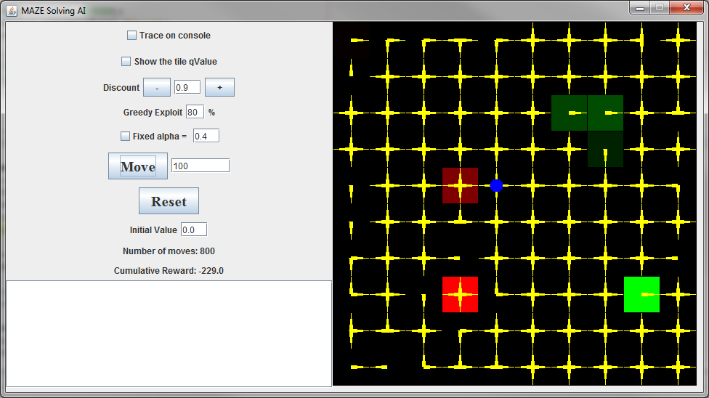

## Appendix 9 – Ability to Learn: Q-Values

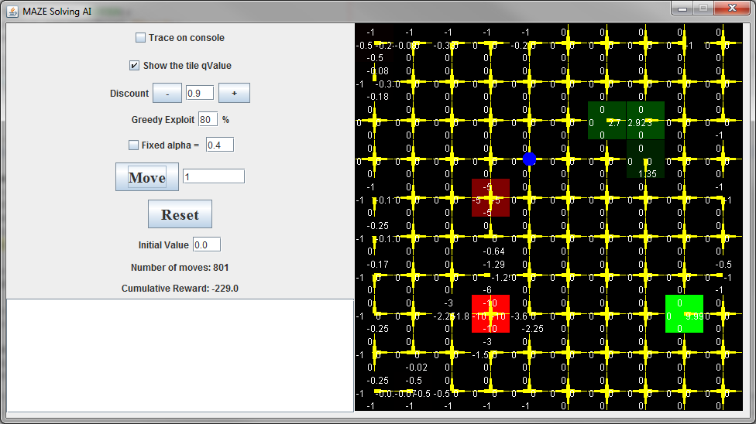

## Appendix 10 – Ability to Adapt

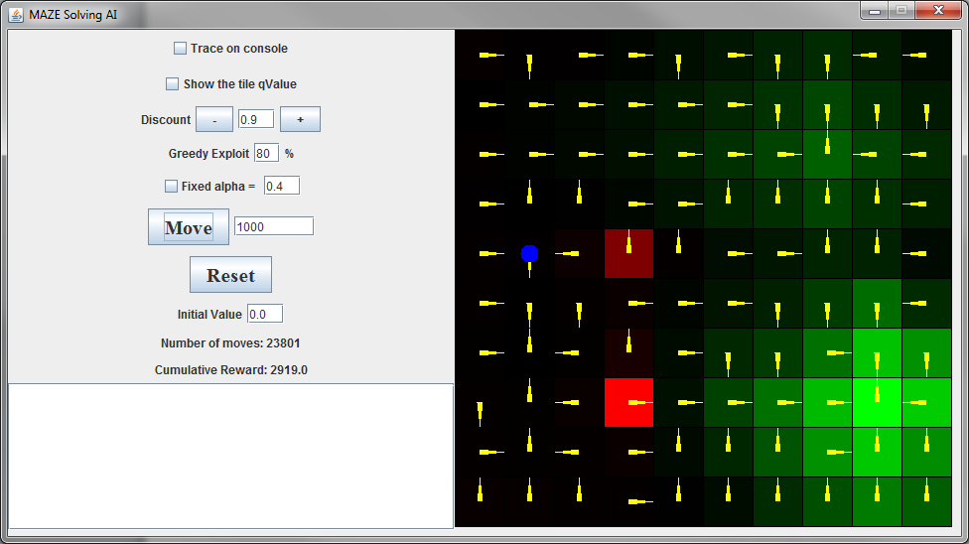

## Appendix 11 – Ability to Adapt: Q-Values

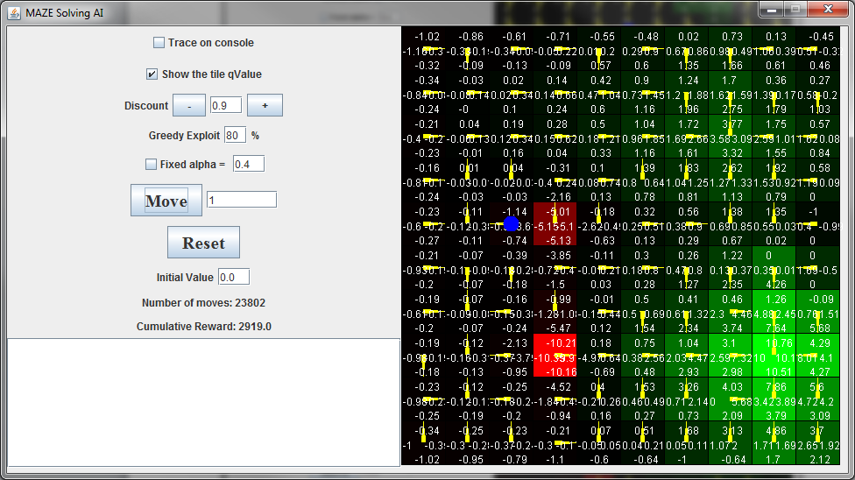

## Appendix 12 – CD containing all project files

* QLearningAgent.exe
* User Guide